Sports Hall Booking System by Service Portal(ServiceNow)
1.INTRODUCTION
  - Project Overview
The Sports Hall Booking System is a web-based application developed on the ServiceNow Platform to simplify and automate the process of reserving sports facilities. The system enables users to view available sports halls, check time slot availability, submit booking requests, receive booking confirmations, and manage reservations through a user-friendly Service Portal. The application eliminates manual booking processes, reduces scheduling conflicts, and provides administrators with centralized control over sports hall management. It also incorporates automated workflows, email notifications, approval processes, and business rules to improve operational efficiency.
  - Purpose
The primary purpose of this project is to develop an efficient online booking system that allows users to reserve sports halls anytime without manual intervention. The system aims to:
- Automate the sports hall reservation process.
- Prevent duplicate or overlapping bookings.
- Provide real-time hall availability.
- Reduce paperwork and administrative effort.
- Improve booking transparency and user experience.
- Maintain centralized booking records within ServiceNow.
2. IDEATION PHASE
2.1 Problem Statement
Many educational institutions and sports facilities still manage sports hall reservations manually through registers, phone calls, or emails. This approach often leads to double bookings, scheduling conflicts, delayed approvals, lack of transparency, and inefficient record management.
The project addresses these issues by implementing an automated booking system using ServiceNow that streamlines reservation management while ensuring data accuracy and better resource utilization.
2.2 Empathy Map Canvas
The empathy map helps understand the needs and expectations of the users.
Thinks
- Wants a quick booking process.
- Expects real-time availability.
- Wants confirmation immediately.
- Needs a reliable booking system.
Feels
- Frustrated by booking delays.
- Confused by unavailable time slots.
- Concerned about booking conflicts.
- Happy with instant confirmations.
Says
- "I need to book the hall quickly."
- "Is the hall available?"
- "Can I modify my booking?"
- "I need a confirmation email."
Does
- Checks available halls.
- Selects preferred date and time.
- Submits booking requests.
- Views booking status.
- Cancels bookings if necessary.
Pain Points
- Double bookings.
- Manual approval delays.
- No centralized booking records.
- Poor communication.
Gains
- Easy online booking.
- Instant notifications.
- Accurate scheduling.
- Better user experience.
2.3 Brainstorming
Several ideas were considered before selecting the final solution:
- Online sports hall booking
- Real-time availability checking
- Automated booking approval
- Email notifications
- Booking cancellation management
- Service Portal interface
- Admin dashboard
- Business Rules for validation
- Reporting and analytics
The ServiceNow platform was selected because of its workflow automation, low-code development capabilities, and integrated notification features.
3. REQUIREMENT ANALYSIS
3.1 Customer Journey map
The customer journey consists of the following stages:
- User logs into the Service Portal.
- User searches available sports halls.
- System displays available time slots.
- User submits booking request.
- Booking is validated.
- Manager approval (if required).
- Booking confirmation notification.
- User views booking details.
- User modifies or cancels booking if needed.
3.2 Solution Requirement
Functional Requirements
- User Registration/Login
- Sports Hall Selection
- Time Slot Selection
- Booking Form
- Booking Validation
- Approval Workflow
- Email Notifications
- Booking Status Tracking
- Cancellation Management
- Administrator Dashboard
Non-Functional Requirements
- User-friendly interface
- Secure authentication
- Fast response time
- High availability
- Reliable data storage
- Scalability
- Data integrity
3.3 Data Flow Diagram
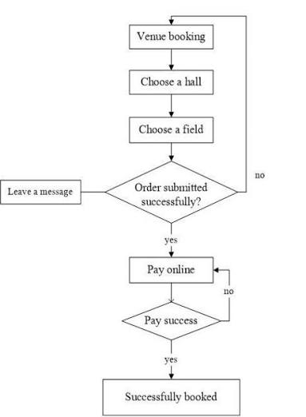
3.4 Technology Stack
Component | Technology
Platform | ServiceNow
Development | ServiceNow Studio
Frontend | Service Portal
Backend | ServiceNow Tables
Workflow | Flow Designer
Automation | Business Rules
Notifications | Email Notifications
Database | ServiceNow Database
Scripting | JavaScript (Server-side)

4. PROJECT DESIGN
4.1 Problem Solution Fit
The proposed solution effectively solves the identified challenges by automating the booking lifecycle.
Problems addressed include:
- Manual booking → Online booking
- Double booking → Availability validation
- Paper records → Digital records
- Manual notifications → Automated emails
- Delayed approval → Workflow automation
4.2 Proposed Solution
The Sports Hall Booking System provides an integrated online platform where users can reserve sports facilities through the Service Portal. The system validates bookings, prevents schedule conflicts, sends automatic notifications, and allows administrators to manage reservations efficiently using ServiceNow workflows and business rules.

4.3 Solution Architecture
Architecture Components:
- User
- Service Portal
- Booking Form
- Business Rules
- Flow Designer
- ServiceNow Database
- Notification Engine
- Administrator
Workflow:
User → Service Portal → Booking Form → Validation → Database → Approval Workflow → Email Notification → Confirmation

5. PROJECT PLANNING & SCHEDULING
5.1 Project Planning
Phase | Activity
Phase 1 | Requirement Gathering
Phase 2 | System Design
Phase 3 | Table Creation
Phase 4 | Field Configuration
Phase 5 | Service Portal Design
Phase 6 | Business Rules Development
Phase 7 | Workflow Implementation
Phase 8 | Testing
Phase 9 | Deployment
Phase 10 | Documentation

6. FUNCTIONAL AND PERFORMANCE TESTING
6.1 Performance Testing
The application was tested for:
Functional Testing
- User Login
- Booking Submission
- Availability Validation
- Approval Workflow
- Cancellation
- Email Notification
Performance Testing
- Fast page loading
- Multiple booking requests
- Response time validation
- Database performance
- Notification delivery
The system performed successfully under normal operating conditions with accurate booking processing and timely notifications.

7. RESULTS
7.1 Output Screenshots
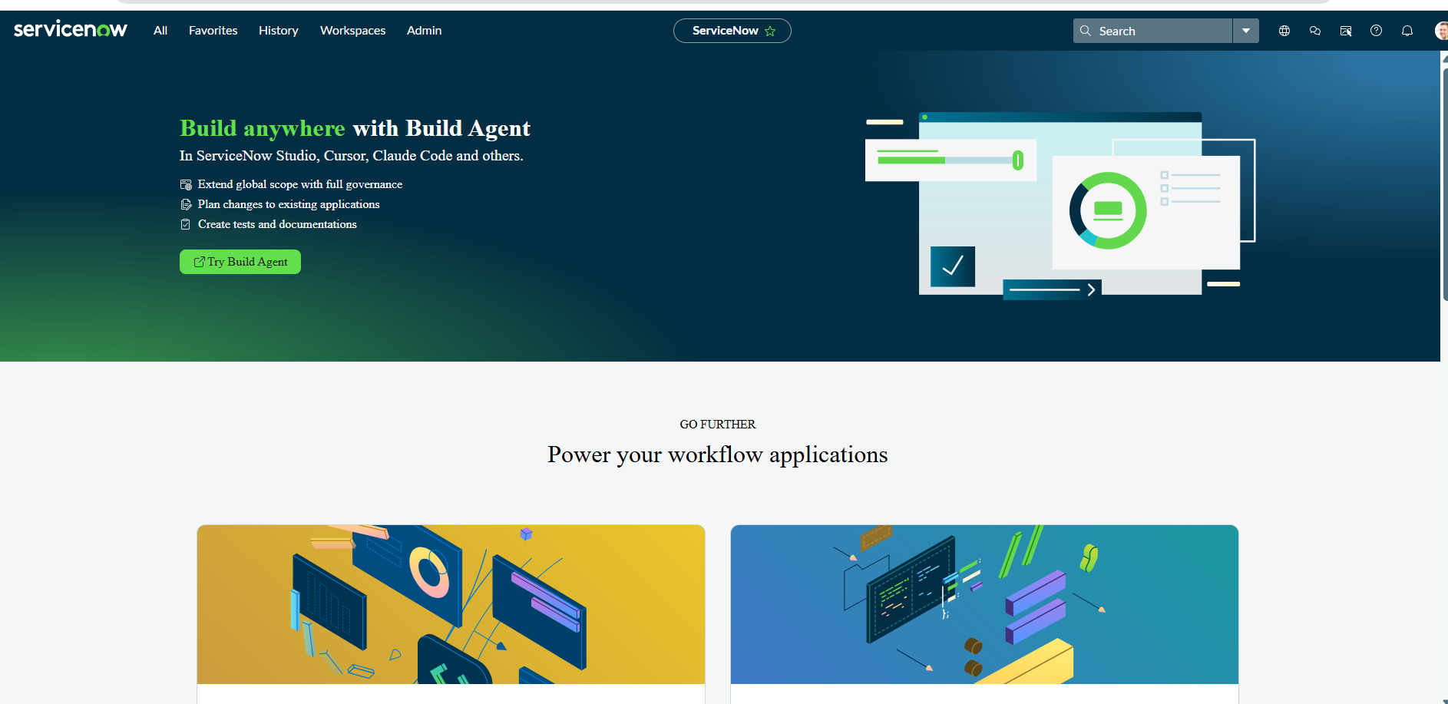
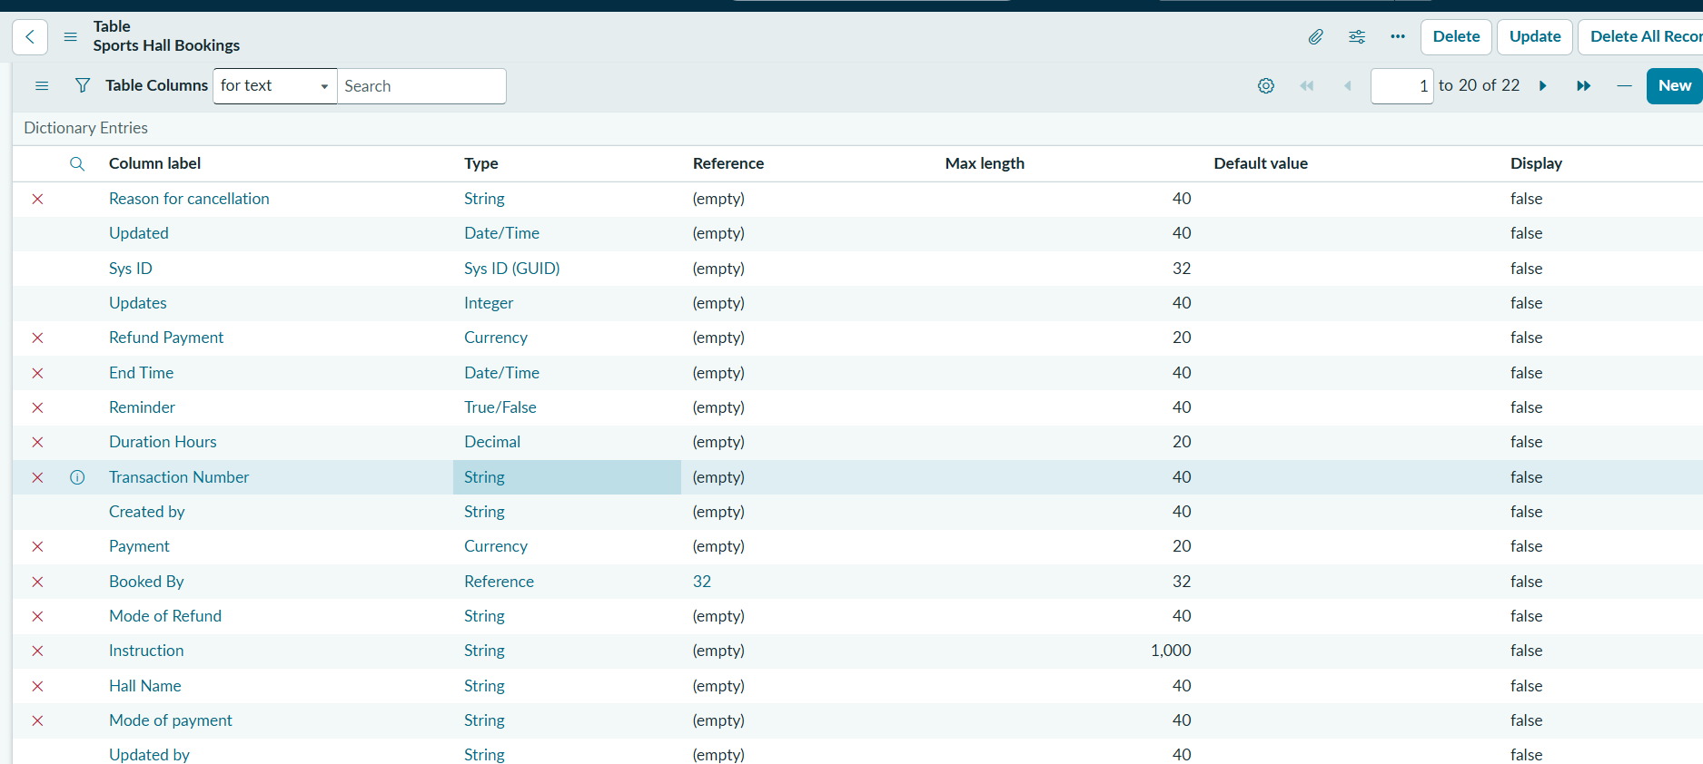
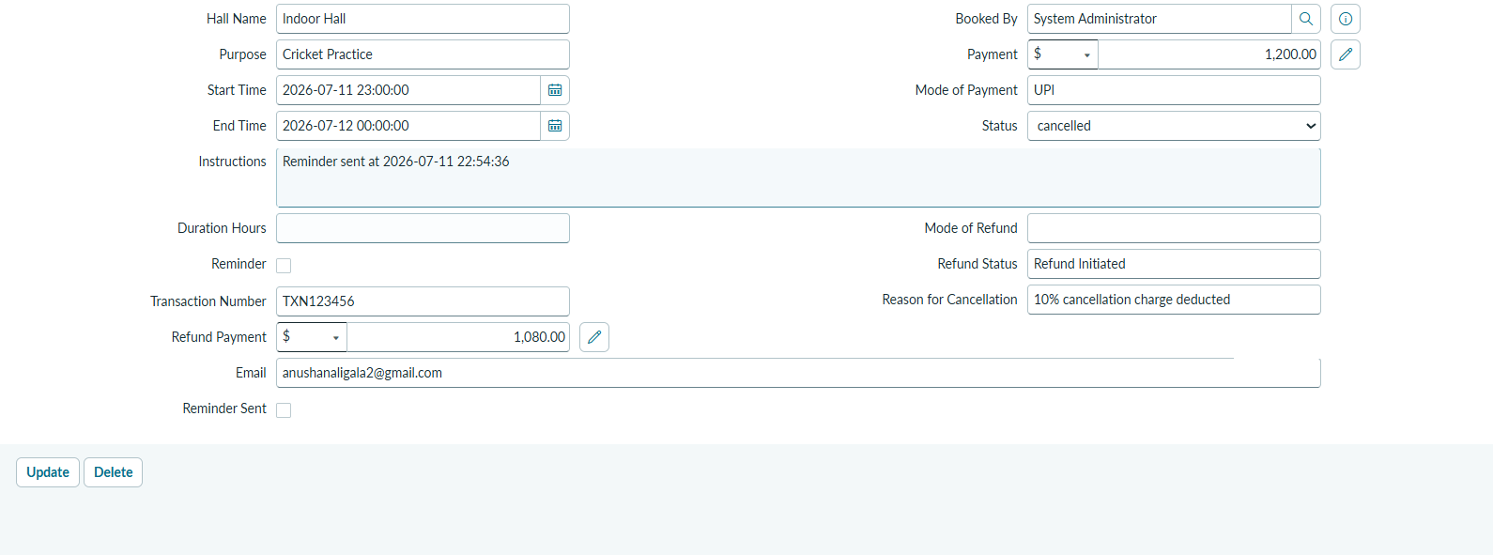
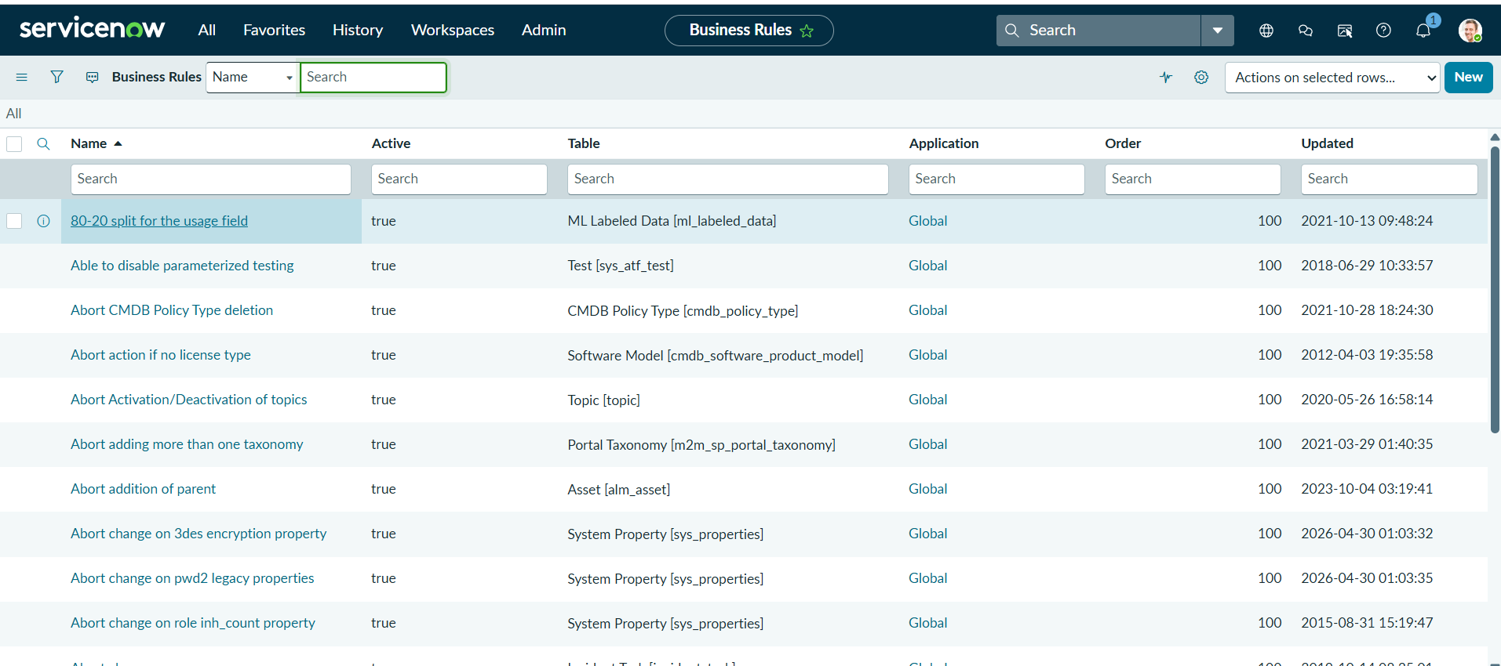
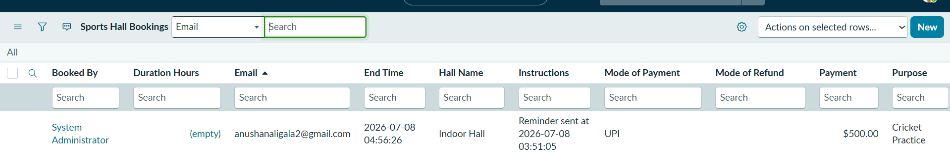
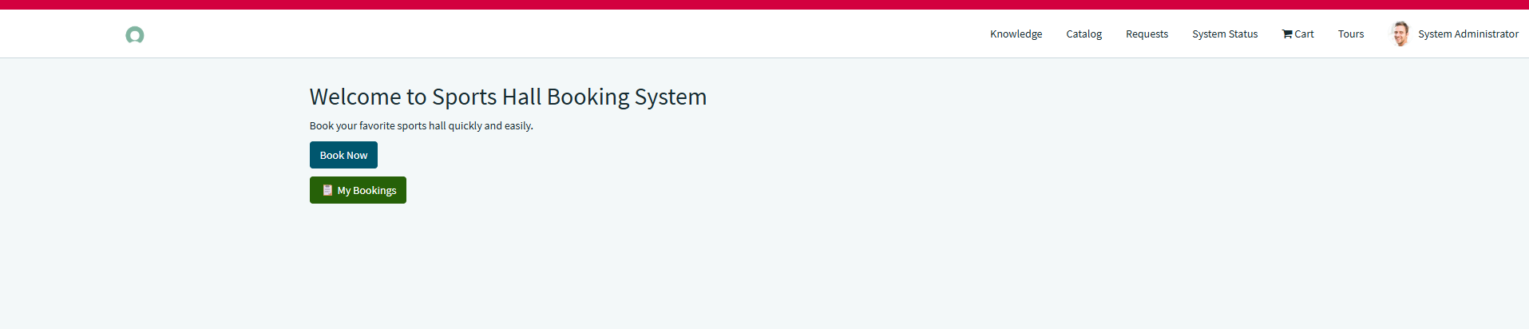
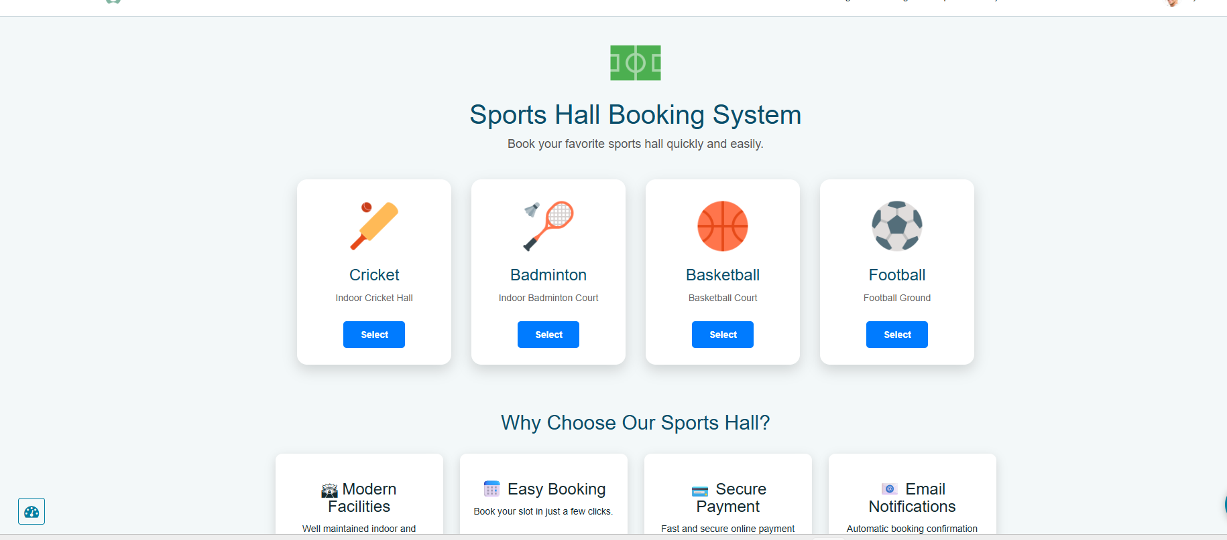
8. ADVANTAGES & DISADVANTAGES
Advantages
- Easy online booking
- Real-time availability checking
- Prevents duplicate bookings
- Automated approvals
- Email notifications
- Centralized booking management
- Reduced paperwork
- Improved efficiency
- Better user experience
- Secure data management
Disadvantages
- Requires internet connectivity
- Depends on ServiceNow platform availability
- Initial setup requires configuration
- User training may be needed
- Platform licensing costs
- CONCLUSION
The Sports Hall Booking System successfully automates the reservation process using the ServiceNow platform. The application provides a reliable, efficient, and user-friendly solution for managing sports hall bookings. Through workflow automation, business rules, and Service Portal integration, the system minimizes manual work, prevents scheduling conflicts, improves transparency, and enhances the overall booking experience for both users and administrators.
- FUTURE SCOPE
Future enhancements include:
- Mobile application integration
- QR code-based booking verification
- Online payment gateway integration
- AI-based slot recommendations
- Calendar synchronization
- SMS and WhatsApp notifications
- Dashboard analytics
- Multi-location sports facility management
- Feedback and rating system
- Biometric attendance integration

11. APPENDIX
Source Code:
Homepage Widget HTML
<h2>Welcome to Sports Hall Booking System</h2>
<p>Book your favorite sports hall quickly and easily.</p>
<p><a class="btn btn-primary" href="/sp?id=booking">Book Now</a></p>
<p><a class="btn btn-success" href="/sp?id=my_bookings">My Bookings</a></p>
Booking Form Widget HTML
<div class="container">
<h2>Sports Hall Booking Form</h2>
...
</div>
Payment Page HTML
<h2>Payment</h2>
<button class="btn btn-success">Pay Now</button>
Confirmation Page HTML
<h2>Booking Confirmed</h2>
<p>Your booking has been submitted successfully.</p>
Dataset Link
N/A (No external dataset used)
GitHub & Project Demo Link
https://github.com/anushanaligala2005/Sports-Hall-Booking-System-by-Service-Portal
https://drive.google.com/file/d/1sBBc5LueDZIEfpeZetYFetQpxusKjhR4/view?usp=sharingsss

